Moving S3 bucket to Amazon Glacier :

- Select the bucket you want to move to amazon glacier
- Go to properties which is present on right side of the window
- There you see storage management option in the last section when you click it you see a opt-in hyper link click on it
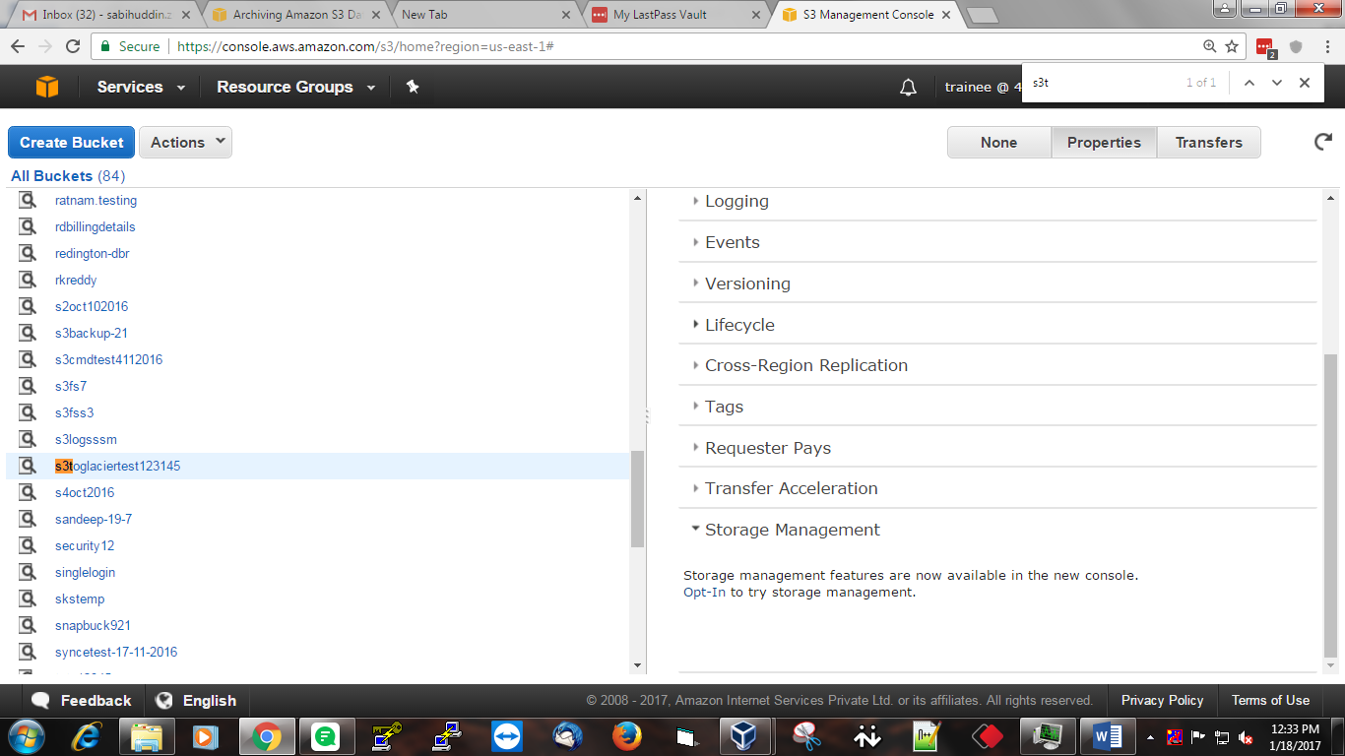

- After clicking the OPT-In hyperlink it will divert you on this below page

- Search the bucket name in the search box which you want to move to amazon glacier select it

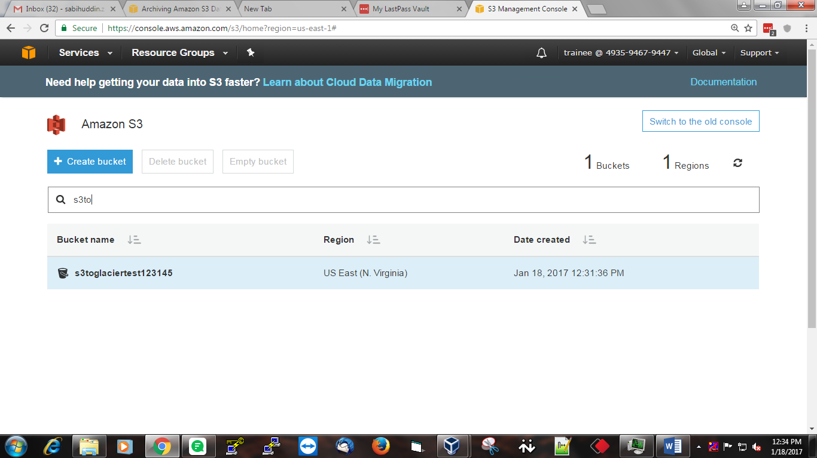

- Click on the bucket the it will give you bucket properties
- There you see a lifecycle policy click on it

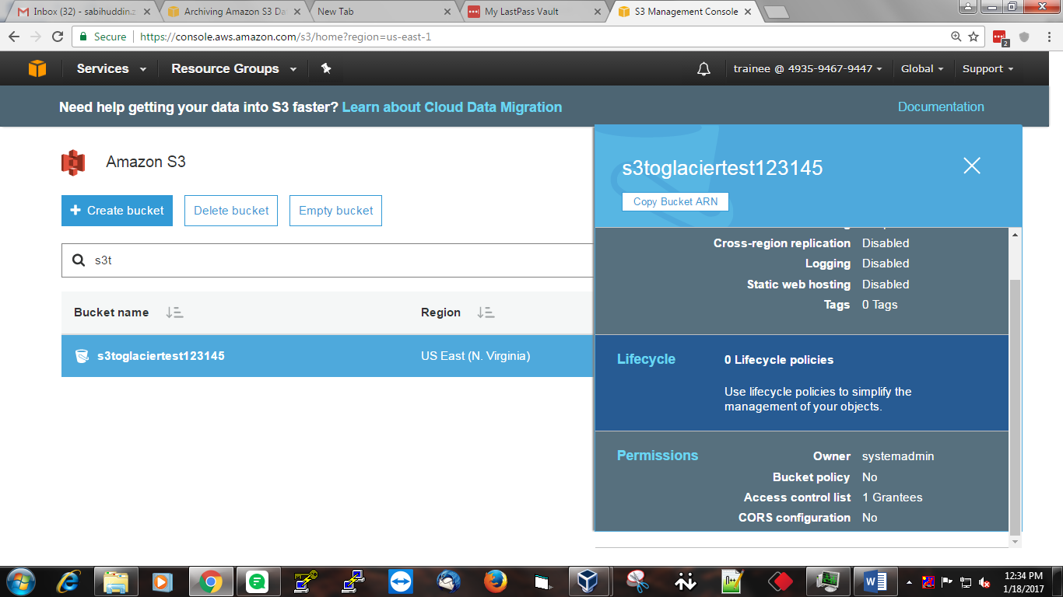

- The below page will open , Select Add lifecycle Rule

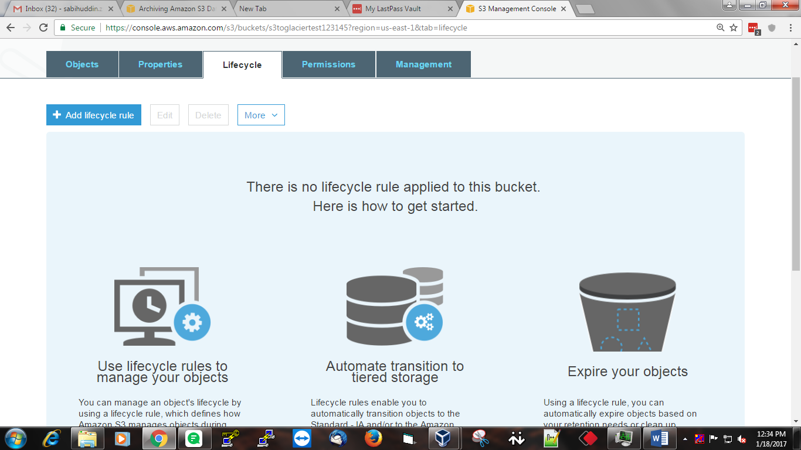
- Fill the required rule name
- Add filter if you want to filter any objects in the bucket which you don’t want to move eg .txt .jpeg etc

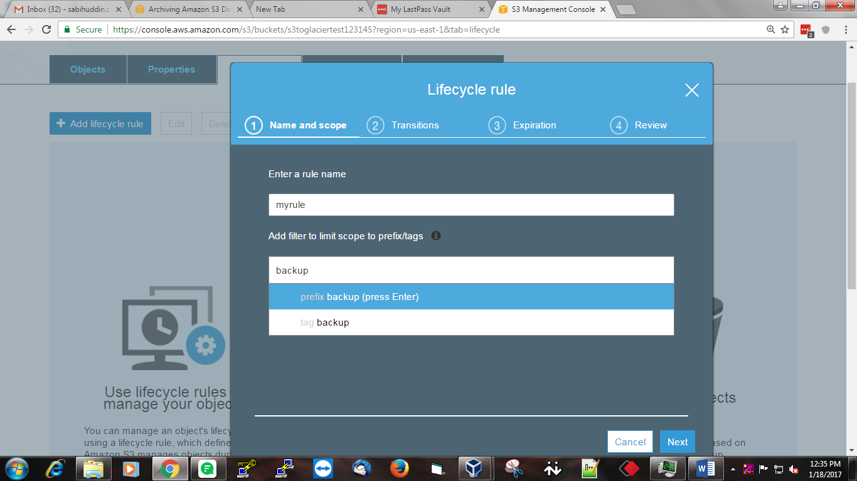

- After clickling next It will take you to the Configure transition page
- Which have to options
    - Current Version
    - Previous Version

- Here check from where you want to transit data from s3 to glacier or glacier to s3
- Since we are interested to transfer data from current version which is in S3
- So we will select Current Version
- Click Add transitioin

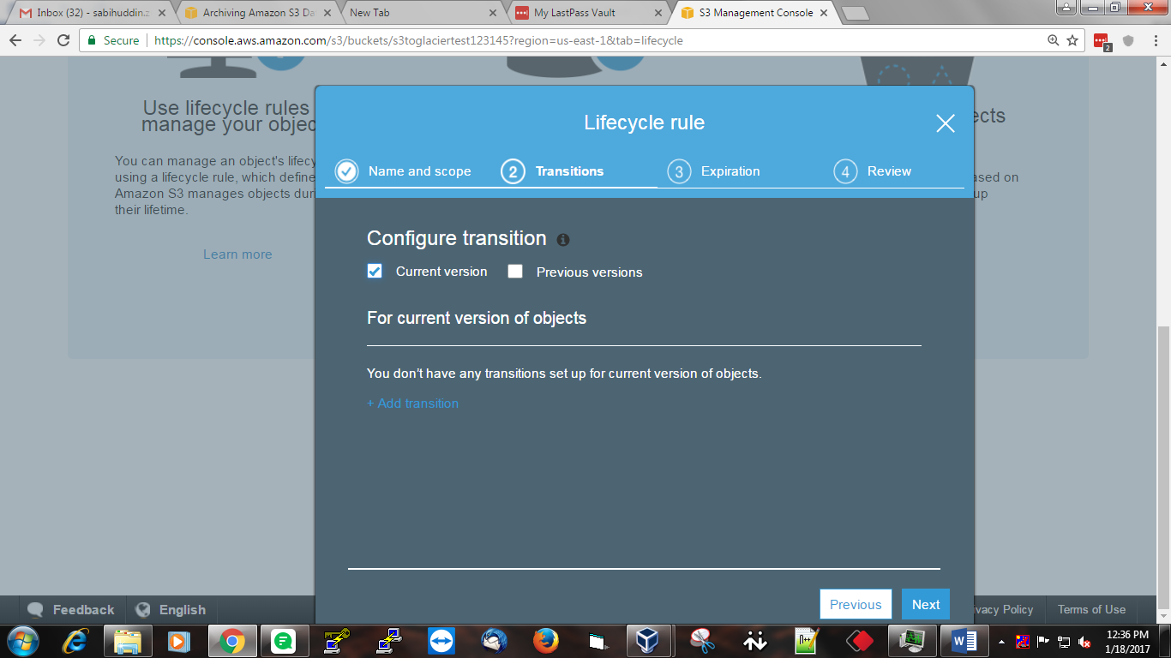

- Select from where you want to move data to Standar IA or glacier and add in no days you want to send the data to the glacier

- Click next
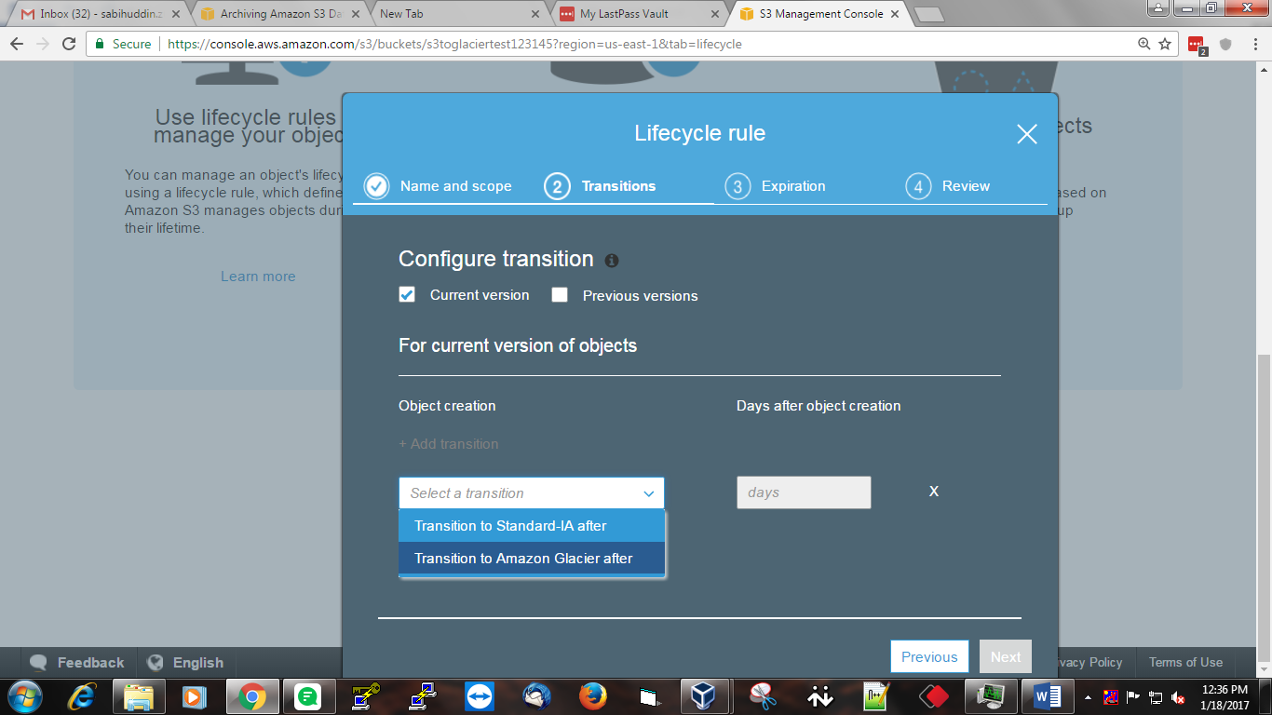

- It will take you to the configure expiration page
- Here you can select what to do with bucket/object after it has been send to glacier

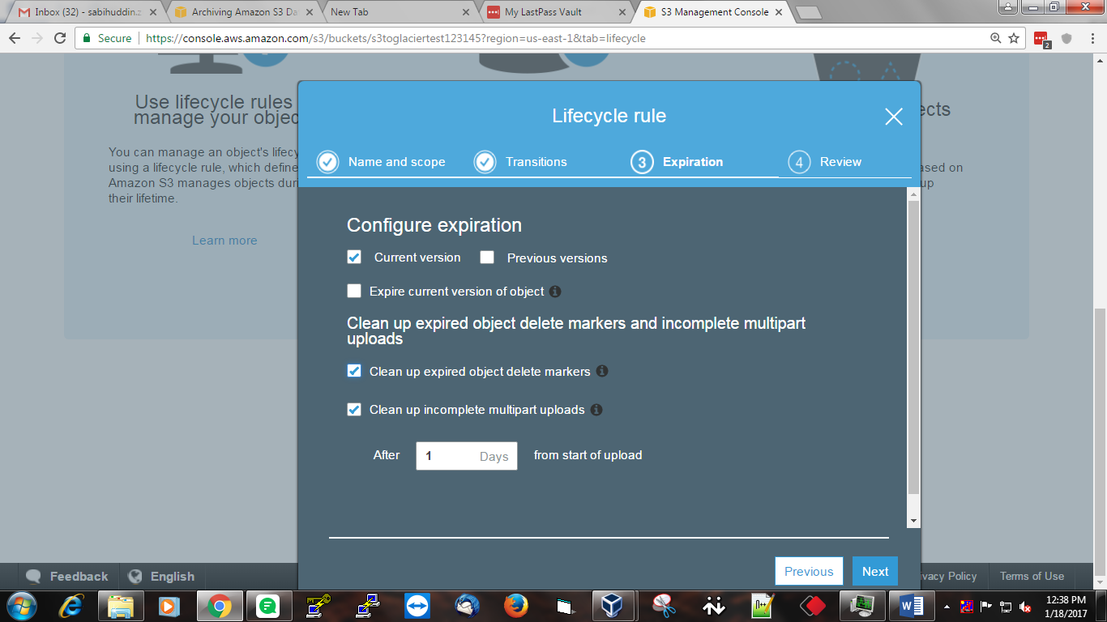
- Click next then your rule has been added
- You can verify your rule by clicking lifecycle tab

